Screenshots of the O/P

1. Task 1 **Identifying Approval Trends**
2. Determine the number of drugs approved each year and provide insights into the yearly trends.

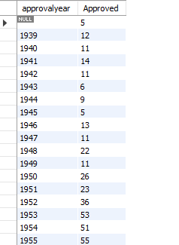

1. Identify the top three years that got the highest and lowest approvals, in descending and ascending order, respectively.

DESC Order

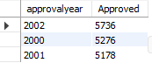

ASC Order

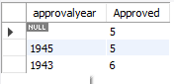

1. Explore approval trends over the years based on sponsors.

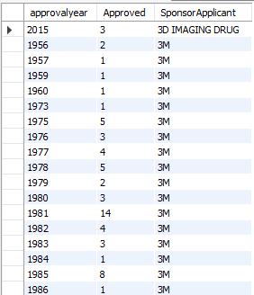

1. Rank sponsors based on the total number of approvals they received each year between 1939 and 1960.

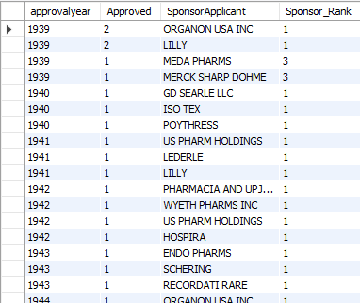

1. Task 2: Segmentation Analysis Based on Drug MarketingStatus
2. Group products based on MarketingStatus. Provide meaningful insights into the segmentation patterns.

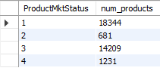

1. Calculate the total number of applications for each MarketingStatus year-wise after the year 2010.

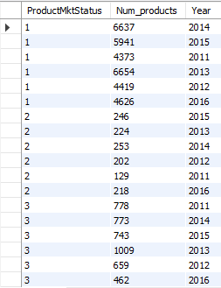

1. Identify the top MarketingStatus with the maximum number of applications and analyze its trend over time.

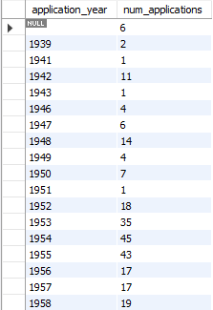

1. **Task 3: Analyzing Products**
2. Categorize Products by dosage form and analyze their distribution.

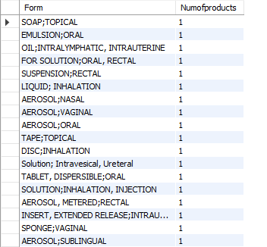

1. Calculate the total number of approvals for each dosage form and identify the most successful forms.

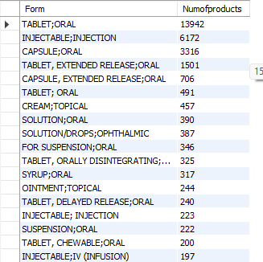

1. Investigate yearly trends related to successful forms.

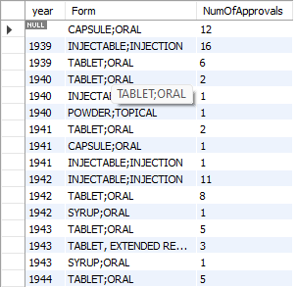

1. TAsk 4
2. Analyze drug approvals based on the therapeutic evaluation code (TE_Code).



1. Determine the therapeutic evaluation code (TE_Code) with the highest number of Approvals in each year

